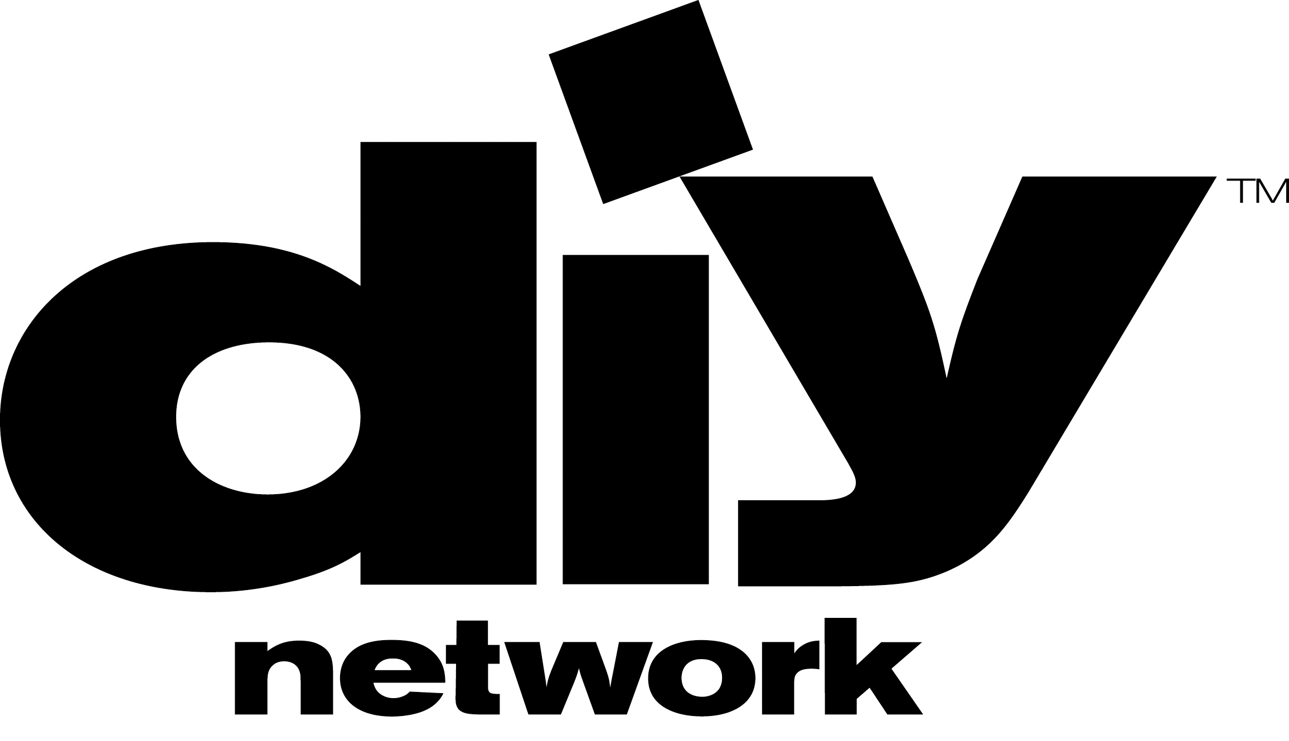

METALWORKERS!
FABRICATORS!
IRONWORKERS!
WELDERS!

THE DIY DOMINATOR – METAL FABRICATORS’ COMPETITION
Hosted by COOL TOOLS’ Chris Grundy

Do you have what it takes to be the next DIY DOMINATOR?

THE DIY DOMINATOR, a new DIY Network series, pits three of the country’s top welders/fabricators in a showdown for one grand prize. In this episode, competitors show off their speed, ability and problem-solving ingenuity in a battle royale of MIG! TIG! STICK! CUTTING! & GRINDING!

If you would like to participate in this competition and have the skills to be the best welder/fabricator, let us know. Please fill out and send us THE DIY DOMINATOR QUESTIONAIRRE. We need to know: your level of skill in the trade, prominent projects you’ve worked on, your “cred” in the welding/fabricating field, and why you think you have what it takes to be THE DIY DOMINATOR!

The showdown is tentatively scheduled for April 19th, 2010 in Denver CO. The top three contestants will be flown in with a three-day commitment plus paid lodgings. Runners-up receive a stipend for participating (TBD). The winner receives a monetary Grand Prize (TBD).

For more info, or to receive the Questionnaire to participate, contact Scott Hiller:

Shiller@highnoontv.com ph: 303.712.3308

DIY DOMINATOR is produced by High Noon Entertainment, based in Denver Colorado, which also produces DIY’s Cool Tools and Deconstruction, Food Network’s Unwrapped and Food Network Challenge, and HGTV’s top-rated My First Place. DIY Network reaches over 52 million homes. The website, www.DIYnetwork.com, has attracted 2.8 million users in a single month.

