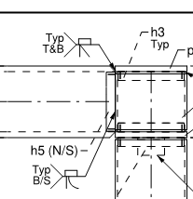

What designation would you call this tube to tube connection?(just NS&FS)

It is a natural (no prep) flare-bevel with ¼” root opening and has a solid backing plate inside the HSS8x8x5/8 tube and it is welded flush with the face of the tube.